1 run......

Downloading: 100%

268M/268M [00:12<00:00, 22.9MB/s]

training 1 epoch...

63.46404552459717 seconds used......

1 training finished! average train loss: 0.6560075393217242

evaluating...

Confusion matrix, without normalization

[[ 40 102 48]

[ 21 354 40]

[ 36 104 573]]

Normalized confusion matrix

[[0.21052632 0.53684211 0.25263158]

[0.05060241 0.85301205 0.09638554]

[0.05049088 0.14586255 0.80364656]]

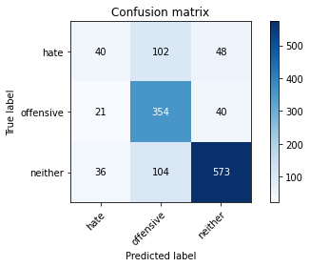

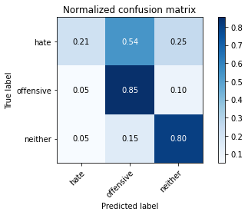

precision recall f1-score support

hate 0.41 0.21 0.28 190

offensive 0.63 0.85 0.73 415

neither 0.87 0.80 0.83 713

accuracy 0.73 1318

macro avg 0.64 0.62 0.61 1318

weighted avg 0.73 0.73 0.72 1318

average eval_loss: 0.6215528042027445, accuracy: 0.7336874051593323

training 2 epoch...

62.8866503238678 seconds used......

2 training finished! average train loss: 0.46858472803719026

evaluating...

Confusion matrix, without normalization

[[ 84 47 59]

[ 56 305 54]

[ 69 29 615]]

Normalized confusion matrix

[[0.44210526 0.24736842 0.31052632]

[0.13493976 0.73493976 0.13012048]

[0.09677419 0.04067321 0.86255259]]

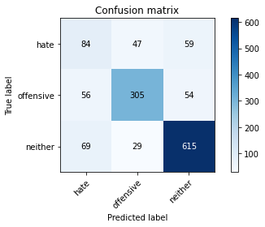

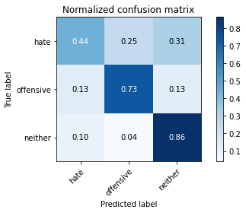

precision recall f1-score support

hate 0.40 0.44 0.42 190

offensive 0.80 0.73 0.77 415

neither 0.84 0.86 0.85 713

accuracy 0.76 1318

macro avg 0.68 0.68 0.68 1318

weighted avg 0.77 0.76 0.76 1318

average eval_loss: 0.5895160894953844, accuracy: 0.7617602427921093

training 3 epoch...

62.942490577697754 seconds used......

3 training finished! average train loss: 0.31200217398313373

evaluating...

Confusion matrix, without normalization

[[ 50 94 46]

[ 40 322 53]

[ 69 77 567]]

Normalized confusion matrix

[[0.26315789 0.49473684 0.24210526]

[0.09638554 0.77590361 0.12771084]

[0.09677419 0.10799439 0.79523142]]

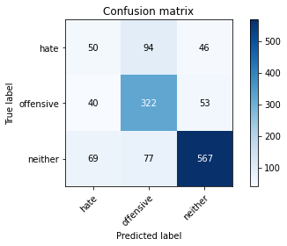

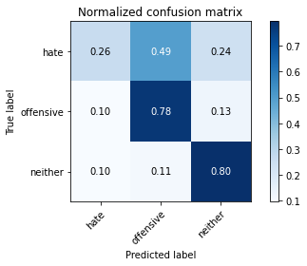

precision recall f1-score support

hate 0.31 0.26 0.29 190

offensive 0.65 0.78 0.71 415

neither 0.85 0.80 0.82 713

accuracy 0.71 1318

macro avg 0.61 0.61 0.61 1318

weighted avg 0.71 0.71 0.71 1318

average eval_loss: 0.7132426491289428, accuracy: 0.712443095599393

training 4 epoch...

62.88734674453735 seconds used......

4 training finished! average train loss: 0.15430236070488507

evaluating...

Confusion matrix, without normalization

[[ 58 91 41]

[ 34 347 34]

[ 98 78 537]]

Normalized confusion matrix

[[0.30526316 0.47894737 0.21578947]

[0.08192771 0.83614458 0.08192771]

[0.13744741 0.10939691 0.75315568]]

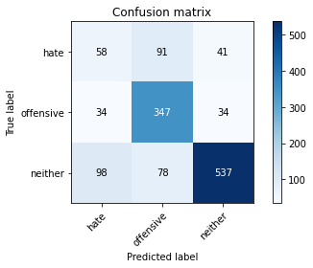

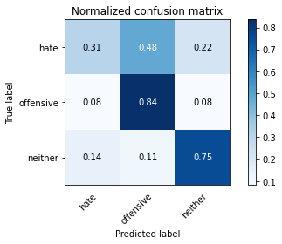

precision recall f1-score support

hate 0.31 0.31 0.31 190

offensive 0.67 0.84 0.75 415

neither 0.88 0.75 0.81 713

accuracy 0.71 1318

macro avg 0.62 0.63 0.62 1318

weighted avg 0.73 0.71 0.72 1318

average eval_loss: 0.8768660974773493, accuracy: 0.7147192716236722

training 5 epoch...

62.94986534118652 seconds used......

5 training finished! average train loss: 0.0735806553837501

evaluating...

Confusion matrix, without normalization

[[ 51 89 50]

[ 24 354 37]

[ 75 108 530]]

Normalized confusion matrix

[[0.26842105 0.46842105 0.26315789]

[0.05783133 0.85301205 0.08915663]

[0.10518934 0.15147265 0.74333801]]

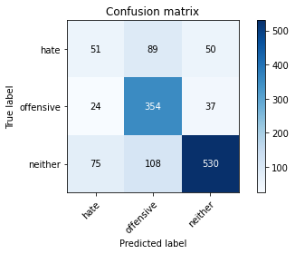

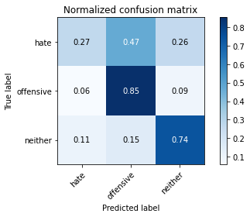

precision recall f1-score support

hate 0.34 0.27 0.30 190

offensive 0.64 0.85 0.73 415

neither 0.86 0.74 0.80 713

accuracy 0.71 1318

macro avg 0.61 0.62 0.61 1318

weighted avg 0.72 0.71 0.71 1318

average eval_loss: 1.093526338537534, accuracy: 0.7094081942336874

training 6 epoch...

62.960487842559814 seconds used......

6 training finished! average train loss: 0.04425767584679983

evaluating...

Confusion matrix, without normalization

[[ 48 79 63]

[ 42 326 47]

[ 86 69 558]]

Normalized confusion matrix

[[0.25263158 0.41578947 0.33157895]

[0.10120482 0.78554217 0.11325301]

[0.12061711 0.09677419 0.7826087 ]]

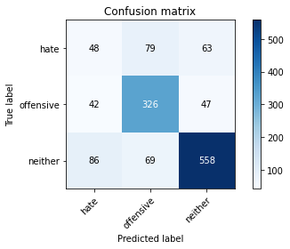

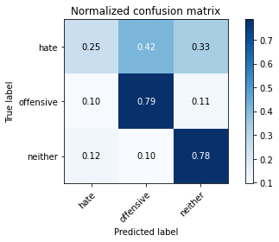

precision recall f1-score support

hate 0.27 0.25 0.26 190

offensive 0.69 0.79 0.73 415

neither 0.84 0.78 0.81 713

accuracy 0.71 1318

macro avg 0.60 0.61 0.60 1318

weighted avg 0.71 0.71 0.71 1318

average eval_loss: 1.177847289226272, accuracy: 0.7071320182094082

training 7 epoch...

62.94641351699829 seconds used......

7 training finished! average train loss: 0.03142516734625778

evaluating...

Confusion matrix, without normalization

[[ 69 67 54]

[ 56 308 51]

[ 77 55 581]]

Normalized confusion matrix

[[0.36315789 0.35263158 0.28421053]

[0.13493976 0.74216867 0.12289157]

[0.10799439 0.07713885 0.81486676]]

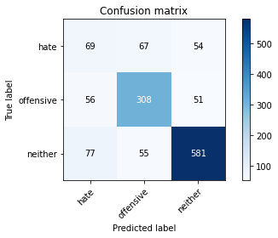

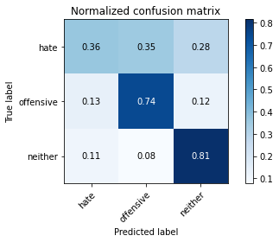

precision recall f1-score support

hate 0.34 0.36 0.35 190

offensive 0.72 0.74 0.73 415

neither 0.85 0.81 0.83 713

accuracy 0.73 1318

macro avg 0.63 0.64 0.64 1318

weighted avg 0.73 0.73 0.73 1318

average eval_loss: 1.1982741039810758, accuracy: 0.7268588770864947

training 8 epoch...

62.92395639419556 seconds used......

8 training finished! average train loss: 0.02288871880249582

evaluating...

Confusion matrix, without normalization

[[ 40 97 53]

[ 23 353 39]

[ 45 103 565]]

Normalized confusion matrix

[[0.21052632 0.51052632 0.27894737]

[0.05542169 0.85060241 0.0939759 ]

[0.0631136 0.14446003 0.79242637]]

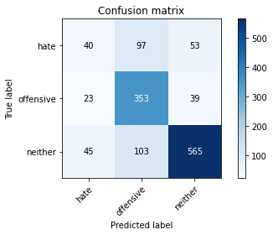

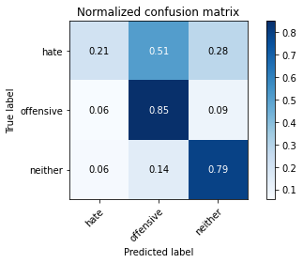

precision recall f1-score support

hate 0.37 0.21 0.27 190

offensive 0.64 0.85 0.73 415

neither 0.86 0.79 0.82 713

accuracy 0.73 1318

macro avg 0.62 0.62 0.61 1318

weighted avg 0.72 0.73 0.71 1318

average eval_loss: 1.4007730127284022, accuracy: 0.7268588770864947

training 9 epoch...

62.91396737098694 seconds used......

9 training finished! average train loss: 0.0328031697455529

evaluating...

Confusion matrix, without normalization

[[ 43 110 37]

[ 26 365 24]

[ 76 119 518]]

Normalized confusion matrix

[[0.22631579 0.57894737 0.19473684]

[0.0626506 0.87951807 0.05783133]

[0.10659187 0.16690042 0.72650771]]

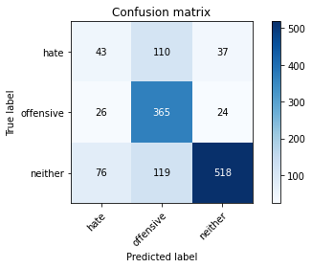

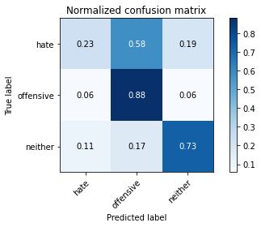

precision recall f1-score support

hate 0.30 0.23 0.26 190

offensive 0.61 0.88 0.72 415

neither 0.89 0.73 0.80 713

accuracy 0.70 1318

macro avg 0.60 0.61 0.59 1318

weighted avg 0.72 0.70 0.70 1318

average eval_loss: 1.4917309604810947, accuracy: 0.7025796661608498

training 10 epoch...

62.94840931892395 seconds used......

10 training finished! average train loss: 0.021217222496519923

evaluating...

Confusion matrix, without normalization

[[ 52 85 53]

[ 31 347 37]

[ 75 92 546]]

Normalized confusion matrix

[[0.27368421 0.44736842 0.27894737]

[0.0746988 0.83614458 0.08915663]

[0.10518934 0.12903226 0.7657784 ]]

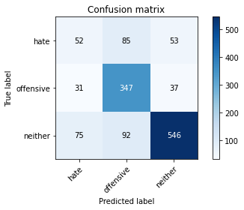

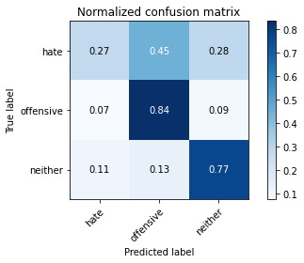

precision recall f1-score support

hate 0.33 0.27 0.30 190

offensive 0.66 0.84 0.74 415

neither 0.86 0.77 0.81 713

accuracy 0.72 1318

macro avg 0.62 0.63 0.62 1318

weighted avg 0.72 0.72 0.71 1318

average eval_loss: 1.455823230246703, accuracy: 0.7169954476479514

2 run......

training 1 epoch...

62.9894642829895 seconds used......

1 training finished! average train loss: 0.6451886700004594

evaluating...

Confusion matrix, without normalization

[[ 4 103 83]

[ 2 348 65]

[ 0 64 649]]

Normalized confusion matrix

[[0.02105263 0.54210526 0.43684211]

[0.00481928 0.83855422 0.15662651]

[0. 0.08976157 0.91023843]]

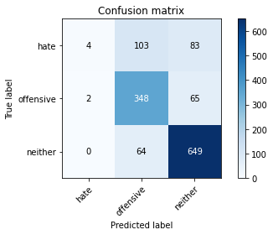

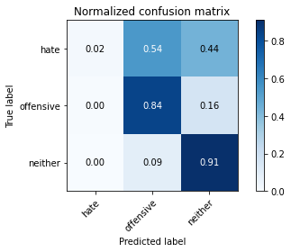

precision recall f1-score support

hate 0.67 0.02 0.04 190

offensive 0.68 0.84 0.75 415

neither 0.81 0.91 0.86 713

accuracy 0.76 1318

macro avg 0.72 0.59 0.55 1318

weighted avg 0.75 0.76 0.71 1318

average eval_loss: 0.6009371456774798, accuracy: 0.7594840667678301

training 2 epoch...

62.96738624572754 seconds used......

2 training finished! average train loss: 0.4636365395262201

evaluating...

Confusion matrix, without normalization

[[ 11 98 81]

[ 8 337 70]

[ 9 57 647]]

Normalized confusion matrix

[[0.05789474 0.51578947 0.42631579]

[0.01927711 0.81204819 0.1686747 ]

[0.01262272 0.0799439 0.90743338]]

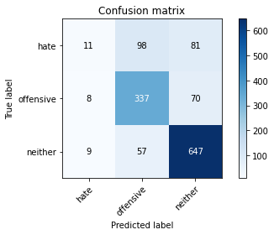

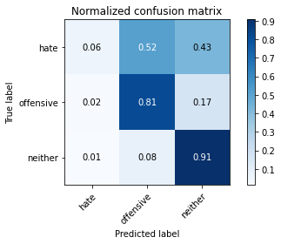

precision recall f1-score support

hate 0.39 0.06 0.10 190

offensive 0.68 0.81 0.74 415

neither 0.81 0.91 0.86 713

accuracy 0.75 1318

macro avg 0.63 0.59 0.57 1318

weighted avg 0.71 0.75 0.71 1318

average eval_loss: 0.5998500061757637, accuracy: 0.7549317147192717

training 3 epoch...

62.99966883659363 seconds used......

3 training finished! average train loss: 0.30257799471609104

evaluating...

Confusion matrix, without normalization

[[ 60 83 47]

[ 32 345 38]

[ 72 80 561]]

Normalized confusion matrix

[[0.31578947 0.43684211 0.24736842]

[0.07710843 0.8313253 0.09156627]

[0.10098177 0.11220196 0.78681627]]

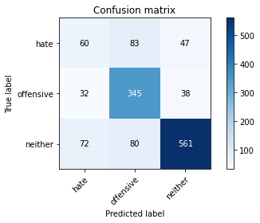

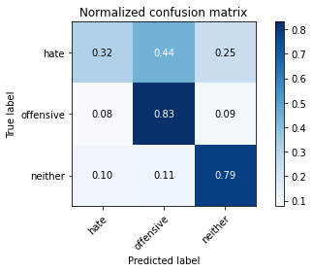

precision recall f1-score support

hate 0.37 0.32 0.34 190

offensive 0.68 0.83 0.75 415

neither 0.87 0.79 0.83 713

accuracy 0.73 1318

macro avg 0.64 0.64 0.64 1318

weighted avg 0.74 0.73 0.73 1318

average eval_loss: 0.7461001624663671, accuracy: 0.7329286798179059

training 4 epoch...

62.95951509475708 seconds used......

4 training finished! average train loss: 0.15686895797013217

evaluating...

Confusion matrix, without normalization

[[ 59 69 62]

[ 47 317 51]

[ 76 51 586]]

Normalized confusion matrix

[[0.31052632 0.36315789 0.32631579]

[0.11325301 0.76385542 0.12289157]

[0.10659187 0.07152875 0.82187938]]

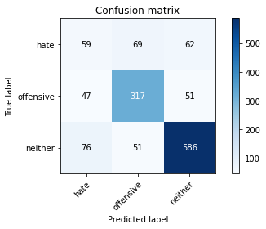

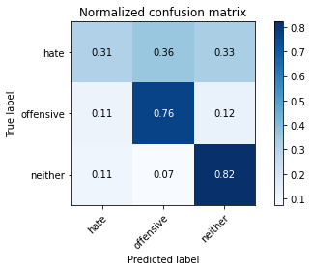

precision recall f1-score support

hate 0.32 0.31 0.32 190

offensive 0.73 0.76 0.74 415

neither 0.84 0.82 0.83 713

accuracy 0.73 1318

macro avg 0.63 0.63 0.63 1318

weighted avg 0.73 0.73 0.73 1318

average eval_loss: 0.8551625582304868, accuracy: 0.7298937784522003

training 5 epoch...

62.96716022491455 seconds used......

5 training finished! average train loss: 0.06891068116101062

evaluating...

Confusion matrix, without normalization

[[ 75 65 50]

[ 48 326 41]

[ 90 65 558]]

Normalized confusion matrix

[[0.39473684 0.34210526 0.26315789]

[0.11566265 0.78554217 0.09879518]

[0.12622721 0.0911641 0.7826087 ]]

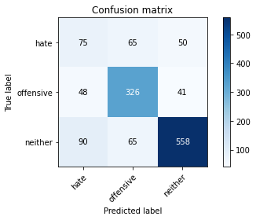

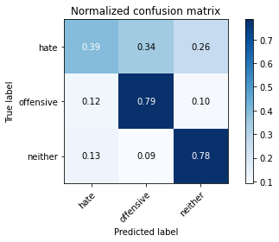

precision recall f1-score support

hate 0.35 0.39 0.37 190

offensive 0.71 0.79 0.75 415

neither 0.86 0.78 0.82 713

accuracy 0.73 1318

macro avg 0.64 0.65 0.65 1318

weighted avg 0.74 0.73 0.73 1318

average eval_loss: 0.9499406595573281, accuracy: 0.7276176024279211

training 6 epoch...

62.96172881126404 seconds used......

6 training finished! average train loss: 0.04759774534787951

evaluating...

Confusion matrix, without normalization

[[ 45 78 67]

[ 27 325 63]

[ 42 57 614]]

Normalized confusion matrix

[[0.23684211 0.41052632 0.35263158]

[0.06506024 0.78313253 0.15180723]

[0.05890603 0.0799439 0.86115007]]

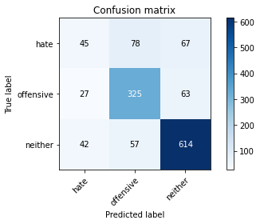

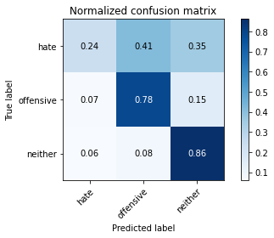

precision recall f1-score support

hate 0.39 0.24 0.30 190

offensive 0.71 0.78 0.74 415

neither 0.83 0.86 0.84 713

accuracy 0.75 1318

macro avg 0.64 0.63 0.63 1318

weighted avg 0.73 0.75 0.73 1318

average eval_loss: 1.1143800056341924, accuracy: 0.7465857359635811

training 7 epoch...

62.96291470527649 seconds used......

7 training finished! average train loss: 0.037476790060476266

evaluating...

Confusion matrix, without normalization

[[ 40 83 67]

[ 25 326 64]

[ 46 60 607]]

Normalized confusion matrix

[[0.21052632 0.43684211 0.35263158]

[0.06024096 0.78554217 0.15421687]

[0.06451613 0.08415147 0.8513324 ]]

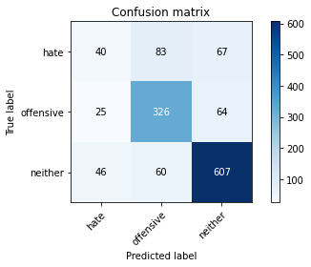

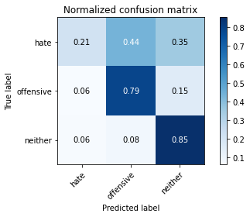

precision recall f1-score support

hate 0.36 0.21 0.27 190

offensive 0.70 0.79 0.74 415

neither 0.82 0.85 0.84 713

accuracy 0.74 1318

macro avg 0.63 0.62 0.61 1318

weighted avg 0.72 0.74 0.72 1318

average eval_loss: 1.2076309043349642, accuracy: 0.7382397572078907

training 8 epoch...

62.93867230415344 seconds used......

8 training finished! average train loss: 0.028943893939214878

evaluating...

Confusion matrix, without normalization

[[ 34 63 93]

[ 29 287 99]

[ 28 30 655]]

Normalized confusion matrix

[[0.17894737 0.33157895 0.48947368]

[0.06987952 0.69156627 0.23855422]

[0.03927069 0.04207574 0.91865358]]

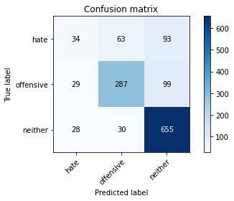

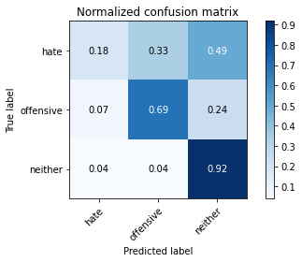

precision recall f1-score support

hate 0.37 0.18 0.24 190

offensive 0.76 0.69 0.72 415

neither 0.77 0.92 0.84 713

accuracy 0.74 1318

macro avg 0.63 0.60 0.60 1318

weighted avg 0.71 0.74 0.72 1318

average eval_loss: 1.2546073713085868, accuracy: 0.7405159332321699

training 9 epoch...

62.960808515548706 seconds used......

9 training finished! average train loss: 0.019049095911392745

evaluating...

Confusion matrix, without normalization

[[ 44 80 66]

[ 40 318 57]

[ 74 61 578]]

Normalized confusion matrix

[[0.23157895 0.42105263 0.34736842]

[0.09638554 0.76626506 0.1373494 ]

[0.10378682 0.085554 0.81065919]]

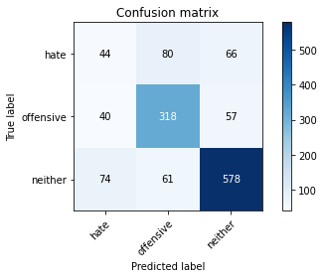

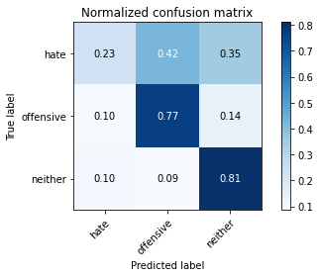

precision recall f1-score support

hate 0.28 0.23 0.25 190

offensive 0.69 0.77 0.73 415

neither 0.82 0.81 0.82 713

accuracy 0.71 1318

macro avg 0.60 0.60 0.60 1318

weighted avg 0.70 0.71 0.71 1318

average eval_loss: 1.322935036186016, accuracy: 0.7132018209408194

training 10 epoch...

62.95701360702515 seconds used......

10 training finished! average train loss: 0.014641469817682723

evaluating...

Confusion matrix, without normalization

[[ 59 88 43]

[ 41 332 42]

[102 70 541]]

Normalized confusion matrix

[[0.31052632 0.46315789 0.22631579]

[0.09879518 0.8 0.10120482]

[0.1430575 0.09817672 0.75876578]]

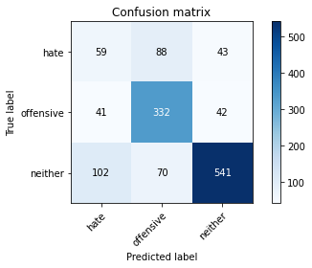

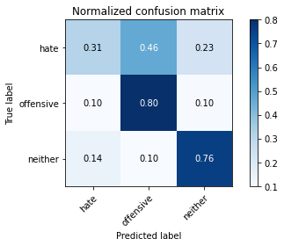

precision recall f1-score support

hate 0.29 0.31 0.30 190

offensive 0.68 0.80 0.73 415

neither 0.86 0.76 0.81 713

accuracy 0.71 1318

macro avg 0.61 0.62 0.61 1318

weighted avg 0.72 0.71 0.71 1318

average eval_loss: 1.3948122267470215, accuracy: 0.7071320182094082

3 run......

training 1 epoch...

62.97894477844238 seconds used......

1 training finished! average train loss: 0.6616106389934181

evaluating...

Confusion matrix, without normalization

[[ 48 54 88]

[ 20 287 108]

[ 10 30 673]]

Normalized confusion matrix

[[0.25263158 0.28421053 0.46315789]

[0.04819277 0.69156627 0.26024096]

[0.01402525 0.04207574 0.94389902]]

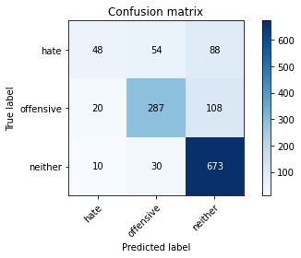

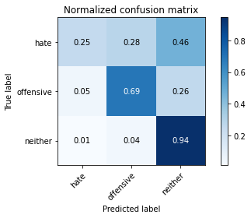

precision recall f1-score support

hate 0.62 0.25 0.36 190

offensive 0.77 0.69 0.73 415

neither 0.77 0.94 0.85 713

accuracy 0.76 1318

macro avg 0.72 0.63 0.65 1318

weighted avg 0.75 0.76 0.74 1318

average eval_loss: 0.5711723674427379, accuracy: 0.7647951441578149

training 2 epoch...

62.9893114566803 seconds used......

2 training finished! average train loss: 0.4596273320026568

evaluating...

Confusion matrix, without normalization

[[ 29 84 77]

[ 16 326 73]

[ 25 42 646]]

Normalized confusion matrix

[[0.15263158 0.44210526 0.40526316]

[0.03855422 0.78554217 0.17590361]

[0.03506311 0.05890603 0.90603086]]

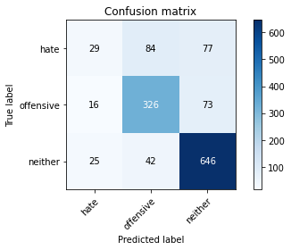

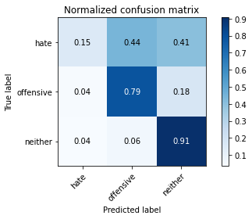

precision recall f1-score support

hate 0.41 0.15 0.22 190

offensive 0.72 0.79 0.75 415

neither 0.81 0.91 0.86 713

accuracy 0.76 1318

macro avg 0.65 0.61 0.61 1318

weighted avg 0.73 0.76 0.73 1318

average eval_loss: 0.609065010692134, accuracy: 0.7594840667678301

training 3 epoch...

62.974955558776855 seconds used......

3 training finished! average train loss: 0.31889926546659225

evaluating...

Confusion matrix, without normalization

[[ 14 123 53]

[ 13 356 46]

[ 15 119 579]]

Normalized confusion matrix

[[0.07368421 0.64736842 0.27894737]

[0.0313253 0.85783133 0.11084337]

[0.02103787 0.16690042 0.81206171]]

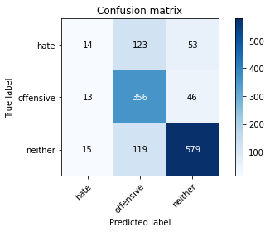

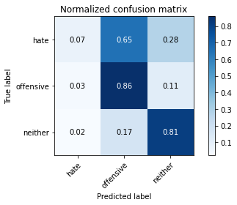

precision recall f1-score support

hate 0.33 0.07 0.12 190

offensive 0.60 0.86 0.70 415

neither 0.85 0.81 0.83 713

accuracy 0.72 1318

macro avg 0.59 0.58 0.55 1318

weighted avg 0.70 0.72 0.69 1318

average eval_loss: 0.7576722317572796, accuracy: 0.720030349013657

training 4 epoch...

62.985408544540405 seconds used......

4 training finished! average train loss: 0.16994336580571073

evaluating...

Confusion matrix, without normalization

[[ 74 64 52]

[ 58 314 43]

[ 97 56 560]]

Normalized confusion matrix

[[0.38947368 0.33684211 0.27368421]

[0.13975904 0.75662651 0.10361446]

[0.13604488 0.07854137 0.78541374]]

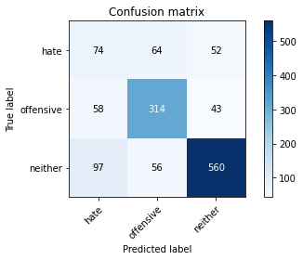

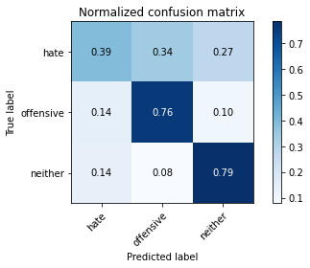

precision recall f1-score support

hate 0.32 0.39 0.35 190

offensive 0.72 0.76 0.74 415

neither 0.85 0.79 0.82 713

accuracy 0.72 1318

macro avg 0.63 0.64 0.64 1318

weighted avg 0.74 0.72 0.73 1318

average eval_loss: 0.8443132891799464, accuracy: 0.7192716236722306

training 5 epoch...

62.933090686798096 seconds used......

5 training finished! average train loss: 0.08006992847280593

evaluating...

Confusion matrix, without normalization

[[ 60 81 49]

[ 42 337 36]

[107 77 529]]

Normalized confusion matrix

[[0.31578947 0.42631579 0.25789474]

[0.10120482 0.81204819 0.08674699]

[0.15007013 0.10799439 0.74193548]]

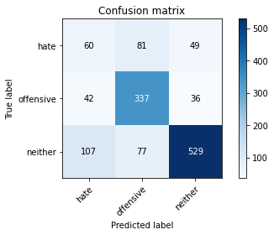

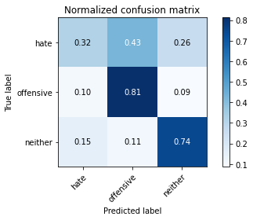

precision recall f1-score support

hate 0.29 0.32 0.30 190

offensive 0.68 0.81 0.74 415

neither 0.86 0.74 0.80 713

accuracy 0.70 1318

macro avg 0.61 0.62 0.61 1318

weighted avg 0.72 0.70 0.71 1318

average eval_loss: 1.0701352935848814, accuracy: 0.7025796661608498

training 6 epoch...

62.96766972541809 seconds used......

6 training finished! average train loss: 0.04710767020493284

evaluating...

Confusion matrix, without normalization

[[ 58 80 52]

[ 37 335 43]

[ 95 87 531]]

Normalized confusion matrix

[[0.30526316 0.42105263 0.27368421]

[0.08915663 0.80722892 0.10361446]

[0.13323983 0.12201964 0.74474053]]

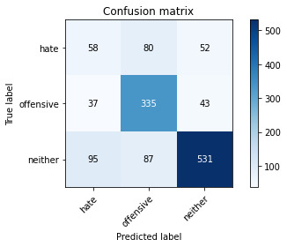

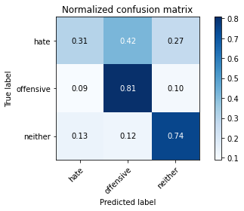

precision recall f1-score support

hate 0.31 0.31 0.31 190

offensive 0.67 0.81 0.73 415

neither 0.85 0.74 0.79 713

accuracy 0.70 1318

macro avg 0.61 0.62 0.61 1318

weighted avg 0.71 0.70 0.70 1318

average eval_loss: 1.1904602890664882, accuracy: 0.701062215477997

training 7 epoch...

62.94250798225403 seconds used......

7 training finished! average train loss: 0.02911214090154395

evaluating...

Confusion matrix, without normalization

[[ 44 72 74]

[ 35 320 60]

[ 66 53 594]]

Normalized confusion matrix

[[0.23157895 0.37894737 0.38947368]

[0.08433735 0.77108434 0.14457831]

[0.09256662 0.0743338 0.83309958]]

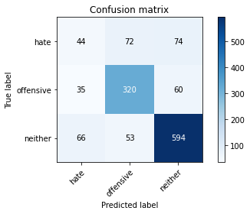

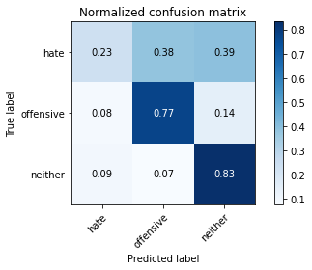

precision recall f1-score support

hate 0.30 0.23 0.26 190

offensive 0.72 0.77 0.74 415

neither 0.82 0.83 0.82 713

accuracy 0.73 1318

macro avg 0.61 0.61 0.61 1318

weighted avg 0.71 0.73 0.72 1318

average eval_loss: 1.1887872648058515, accuracy: 0.7268588770864947

training 8 epoch...

63.03110599517822 seconds used......

8 training finished! average train loss: 0.02642120791073793

evaluating...

Confusion matrix, without normalization

[[ 75 61 54]

[ 63 305 47]

[103 49 561]]

Normalized confusion matrix

[[0.39473684 0.32105263 0.28421053]

[0.15180723 0.73493976 0.11325301]

[0.14446003 0.0687237 0.78681627]]

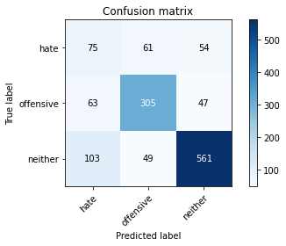

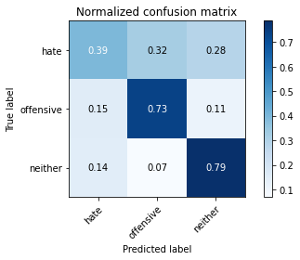

precision recall f1-score support

hate 0.31 0.39 0.35 190

offensive 0.73 0.73 0.73 415

neither 0.85 0.79 0.82 713

accuracy 0.71 1318

macro avg 0.63 0.64 0.63 1318

weighted avg 0.73 0.71 0.72 1318

average eval_loss: 1.2673834345557473, accuracy: 0.7139605462822458

training 9 epoch...

63.07280468940735 seconds used......

9 training finished! average train loss: 0.03028409228758174

evaluating...

Confusion matrix, without normalization

[[ 57 78 55]

[ 38 326 51]

[ 74 73 566]]

Normalized confusion matrix

[[0.3 0.41052632 0.28947368]

[0.09156627 0.78554217 0.12289157]

[0.10378682 0.10238429 0.79382889]]

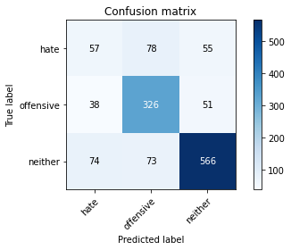

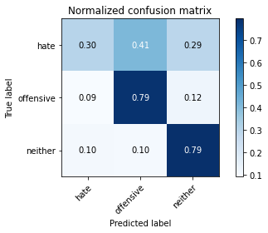

precision recall f1-score support

hate 0.34 0.30 0.32 190

offensive 0.68 0.79 0.73 415

neither 0.84 0.79 0.82 713

accuracy 0.72 1318

macro avg 0.62 0.63 0.62 1318

weighted avg 0.72 0.72 0.72 1318

average eval_loss: 1.2640809082623683, accuracy: 0.720030349013657

training 10 epoch...

63.00054097175598 seconds used......

10 training finished! average train loss: 0.021990582973954495

evaluating...

Confusion matrix, without normalization

[[ 64 57 69]

[ 49 292 74]

[ 73 28 612]]

Normalized confusion matrix

[[0.33684211 0.3 0.36315789]

[0.11807229 0.70361446 0.17831325]

[0.10238429 0.03927069 0.85834502]]

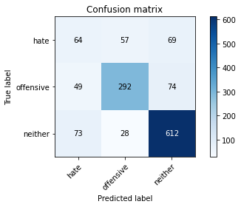

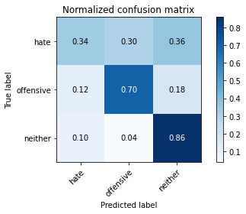

precision recall f1-score support

hate 0.34 0.34 0.34 190

offensive 0.77 0.70 0.74 415

neither 0.81 0.86 0.83 713

accuracy 0.73 1318

macro avg 0.64 0.63 0.64 1318

weighted avg 0.73 0.73 0.73 1318

average eval_loss: 1.2202555668173414, accuracy: 0.7344461305007587

4 run......

training 1 epoch...

63.1111741065979 seconds used......

1 training finished! average train loss: 0.6562487817982323

evaluating...

Confusion matrix, without normalization

[[ 9 103 78]

[ 8 337 70]

[ 16 50 647]]

Normalized confusion matrix

[[0.04736842 0.54210526 0.41052632]

[0.01927711 0.81204819 0.1686747 ]

[0.02244039 0.07012623 0.90743338]]

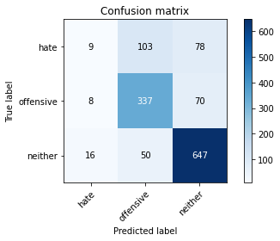

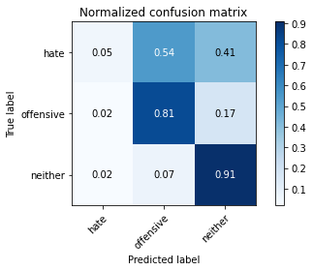

precision recall f1-score support

hate 0.27 0.05 0.08 190

offensive 0.69 0.81 0.74 415

neither 0.81 0.91 0.86 713

accuracy 0.75 1318

macro avg 0.59 0.59 0.56 1318

weighted avg 0.70 0.75 0.71 1318

average eval_loss: 0.6021194543802377, accuracy: 0.7534142640364189

training 2 epoch...

63.00717282295227 seconds used......

2 training finished! average train loss: 0.46520039999586904

evaluating...

Confusion matrix, without normalization

[[ 63 58 69]

[ 46 296 73]

[ 67 26 620]]

Normalized confusion matrix

[[0.33157895 0.30526316 0.36315789]

[0.11084337 0.71325301 0.17590361]

[0.09396914 0.03646564 0.86956522]]

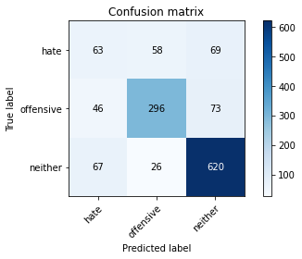

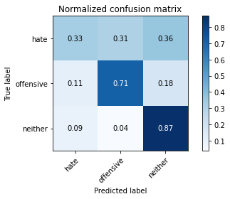

precision recall f1-score support

hate 0.36 0.33 0.34 190

offensive 0.78 0.71 0.74 415

neither 0.81 0.87 0.84 713

accuracy 0.74 1318

macro avg 0.65 0.64 0.64 1318

weighted avg 0.74 0.74 0.74 1318

average eval_loss: 0.6032778160138563, accuracy: 0.7427921092564491

training 3 epoch...

63.00749349594116 seconds used......

3 training finished! average train loss: 0.31147590219082993

evaluating...

Confusion matrix, without normalization

[[ 70 66 54]

[ 57 322 36]

[ 93 47 573]]

Normalized confusion matrix

[[0.36842105 0.34736842 0.28421053]

[0.1373494 0.77590361 0.08674699]

[0.13043478 0.06591865 0.80364656]]

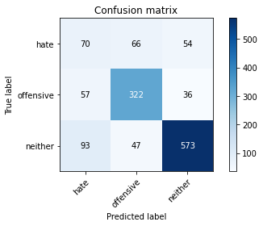

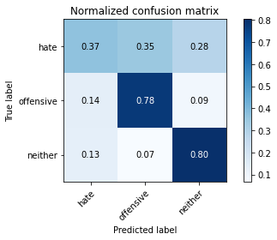

precision recall f1-score support

hate 0.32 0.37 0.34 190

offensive 0.74 0.78 0.76 415

neither 0.86 0.80 0.83 713

accuracy 0.73 1318

macro avg 0.64 0.65 0.64 1318

weighted avg 0.75 0.73 0.74 1318

average eval_loss: 0.6900984256556539, accuracy: 0.7321699544764795

training 4 epoch...

63.055525064468384 seconds used......

4 training finished! average train loss: 0.14477289229249343

evaluating...

Confusion matrix, without normalization

[[ 98 52 40]

[ 84 306 25]

[141 57 515]]

Normalized confusion matrix

[[0.51578947 0.27368421 0.21052632]

[0.20240964 0.7373494 0.06024096]

[0.19775596 0.0799439 0.72230014]]

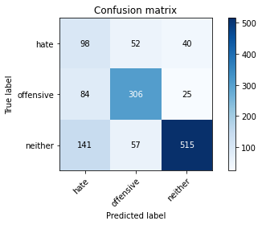

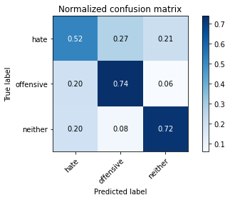

precision recall f1-score support

hate 0.30 0.52 0.38 190

offensive 0.74 0.74 0.74 415

neither 0.89 0.72 0.80 713

accuracy 0.70 1318

macro avg 0.64 0.66 0.64 1318

weighted avg 0.76 0.70 0.72 1318

average eval_loss: 0.9247738204219125, accuracy: 0.697268588770865

training 5 epoch...

62.936474084854126 seconds used......

5 training finished! average train loss: 0.06644979381285067

evaluating...

Confusion matrix, without normalization

[[ 70 56 64]

[ 67 285 63]

[ 74 33 606]]

Normalized confusion matrix

[[0.36842105 0.29473684 0.33684211]

[0.16144578 0.68674699 0.15180723]

[0.10378682 0.04628331 0.84992987]]

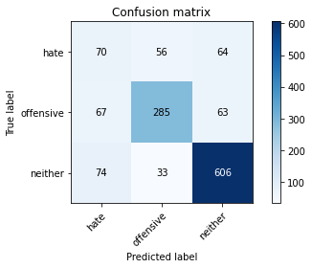

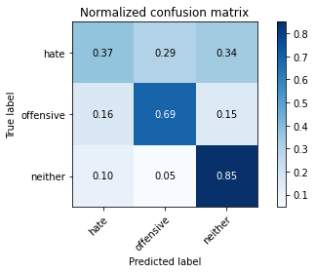

precision recall f1-score support

hate 0.33 0.37 0.35 190

offensive 0.76 0.69 0.72 415

neither 0.83 0.85 0.84 713

accuracy 0.73 1318

macro avg 0.64 0.64 0.64 1318

weighted avg 0.74 0.73 0.73 1318

average eval_loss: 1.0182122393991009, accuracy: 0.7291350531107739

training 6 epoch...

63.07828974723816 seconds used......

6 training finished! average train loss: 0.042915994128307856

evaluating...

Confusion matrix, without normalization

[[ 57 52 81]

[ 52 288 75]

[ 67 31 615]]

Normalized confusion matrix

[[0.3 0.27368421 0.42631579]

[0.1253012 0.6939759 0.18072289]

[0.09396914 0.04347826 0.86255259]]

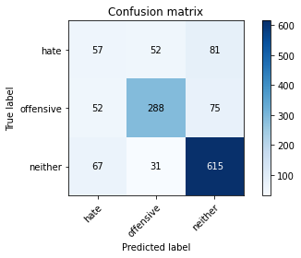

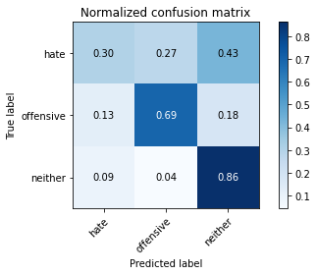

precision recall f1-score support

hate 0.32 0.30 0.31 190

offensive 0.78 0.69 0.73 415

neither 0.80 0.86 0.83 713

accuracy 0.73 1318

macro avg 0.63 0.62 0.62 1318

weighted avg 0.72 0.73 0.72 1318

average eval_loss: 1.1072969337304432, accuracy: 0.7283763277693475

training 7 epoch...

63.02740526199341 seconds used......

7 training finished! average train loss: 0.02701924250837521

evaluating...

Confusion matrix, without normalization

[[ 75 63 52]

[ 60 318 37]

[102 62 549]]

Normalized confusion matrix

[[0.39473684 0.33157895 0.27368421]

[0.14457831 0.76626506 0.08915663]

[0.1430575 0.08695652 0.76998597]]

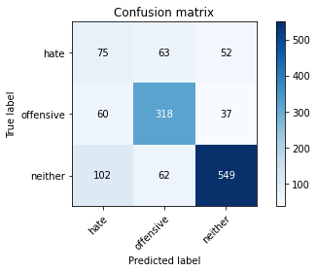

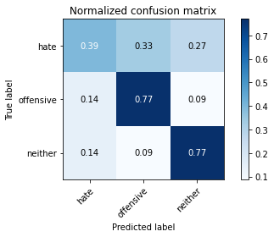

precision recall f1-score support

hate 0.32 0.39 0.35 190

offensive 0.72 0.77 0.74 415

neither 0.86 0.77 0.81 713

accuracy 0.71 1318

macro avg 0.63 0.64 0.64 1318

weighted avg 0.74 0.71 0.72 1318

average eval_loss: 1.2752850006024044, accuracy: 0.7147192716236722

training 8 epoch...

62.99053955078125 seconds used......

8 training finished! average train loss: 0.026718384969226308

evaluating...

Confusion matrix, without normalization

[[ 50 89 51]

[ 46 336 33]

[ 89 96 528]]

Normalized confusion matrix

[[0.26315789 0.46842105 0.26842105]

[0.11084337 0.80963855 0.07951807]

[0.12482468 0.13464236 0.74053296]]

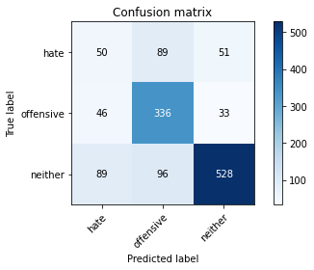

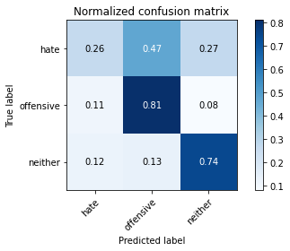

precision recall f1-score support

hate 0.27 0.26 0.27 190

offensive 0.64 0.81 0.72 415

neither 0.86 0.74 0.80 713

accuracy 0.69 1318

macro avg 0.59 0.60 0.59 1318

weighted avg 0.71 0.69 0.70 1318

average eval_loss: 1.3864268976630587, accuracy: 0.6934749620637329

training 9 epoch...

62.98046588897705 seconds used......

9 training finished! average train loss: 0.014756256226663135

evaluating...

Confusion matrix, without normalization

[[ 39 71 80]

[ 31 308 76]

[ 46 45 622]]

Normalized confusion matrix

[[0.20526316 0.37368421 0.42105263]

[0.0746988 0.74216867 0.18313253]

[0.06451613 0.0631136 0.87237027]]

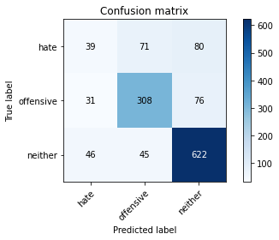

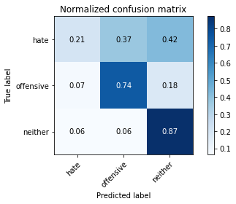

precision recall f1-score support

hate 0.34 0.21 0.25 190

offensive 0.73 0.74 0.73 415

neither 0.80 0.87 0.83 713

accuracy 0.74 1318

macro avg 0.62 0.61 0.61 1318

weighted avg 0.71 0.74 0.72 1318

average eval_loss: 1.402676072987643, accuracy: 0.7352048558421851

training 10 epoch...

63.02470827102661 seconds used......

10 training finished! average train loss: 0.022949075431171924

evaluating...

Confusion matrix, without normalization

[[ 32 79 79]

[ 29 309 77]

[ 39 59 615]]

Normalized confusion matrix

[[0.16842105 0.41578947 0.41578947]

[0.06987952 0.74457831 0.18554217]

[0.05469846 0.08274895 0.86255259]]

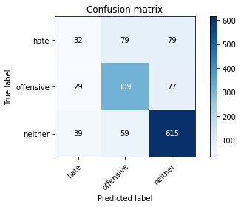

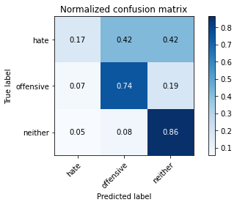

precision recall f1-score support

hate 0.32 0.17 0.22 190

offensive 0.69 0.74 0.72 415

neither 0.80 0.86 0.83 713

accuracy 0.73 1318

macro avg 0.60 0.59 0.59 1318

weighted avg 0.70 0.73 0.71 1318

average eval_loss: 1.3903209232922755, accuracy: 0.7253414264036419

5 run......

training 1 epoch...

63.033162117004395 seconds used......

1 training finished! average train loss: 0.6531861597019383

evaluating...

Confusion matrix, without normalization

[[ 62 80 48]

[ 36 342 37]

[ 63 85 565]]

Normalized confusion matrix

[[0.32631579 0.42105263 0.25263158]

[0.08674699 0.82409639 0.08915663]

[0.08835905 0.11921459 0.79242637]]

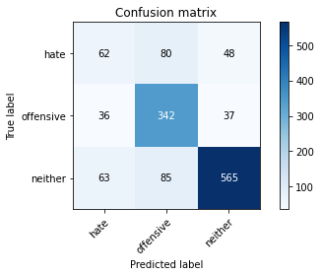

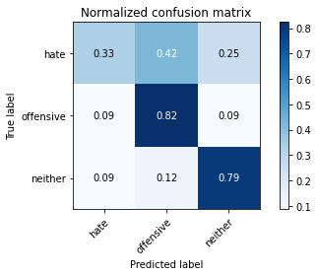

precision recall f1-score support

hate 0.39 0.33 0.35 190

offensive 0.67 0.82 0.74 415

neither 0.87 0.79 0.83 713

accuracy 0.74 1318

macro avg 0.64 0.65 0.64 1318

weighted avg 0.74 0.74 0.73 1318

average eval_loss: 0.6407560886758746, accuracy: 0.7352048558421851

training 2 epoch...

63.02272939682007 seconds used......

2 training finished! average train loss: 0.46680752092447036

evaluating...

Confusion matrix, without normalization

[[ 41 87 62]

[ 25 338 52]

[ 37 62 614]]

Normalized confusion matrix

[[0.21578947 0.45789474 0.32631579]

[0.06024096 0.81445783 0.1253012 ]

[0.05189341 0.08695652 0.86115007]]

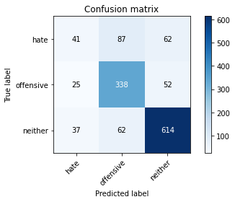

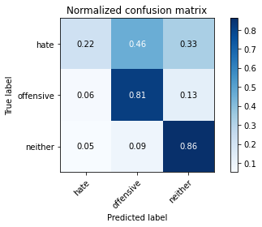

precision recall f1-score support

hate 0.40 0.22 0.28 190

offensive 0.69 0.81 0.75 415

neither 0.84 0.86 0.85 713

accuracy 0.75 1318

macro avg 0.65 0.63 0.63 1318

weighted avg 0.73 0.75 0.74 1318

average eval_loss: 0.611513978152564, accuracy: 0.7534142640364189

training 3 epoch...

62.990418672561646 seconds used......

3 training finished! average train loss: 0.30142404683507407

evaluating...

Confusion matrix, without normalization

[[ 18 89 83]

[ 10 332 73]

[ 20 69 624]]

Normalized confusion matrix

[[0.09473684 0.46842105 0.43684211]

[0.02409639 0.8 0.17590361]

[0.02805049 0.09677419 0.87517532]]

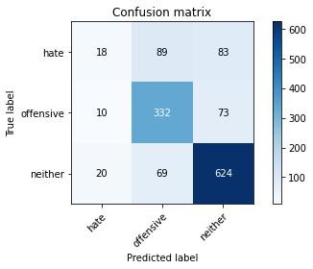

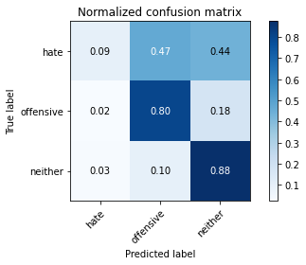

precision recall f1-score support

hate 0.38 0.09 0.15 190

offensive 0.68 0.80 0.73 415

neither 0.80 0.88 0.84 713

accuracy 0.74 1318

macro avg 0.62 0.59 0.57 1318

weighted avg 0.70 0.74 0.71 1318

average eval_loss: 0.7345811277627945, accuracy: 0.7389984825493171

training 4 epoch...

63.047372817993164 seconds used......

4 training finished! average train loss: 0.15570589506393698

evaluating...

Confusion matrix, without normalization

[[ 69 82 39]

[ 60 321 34]

[ 93 90 530]]

Normalized confusion matrix

[[0.36315789 0.43157895 0.20526316]

[0.14457831 0.77349398 0.08192771]

[0.13043478 0.12622721 0.74333801]]

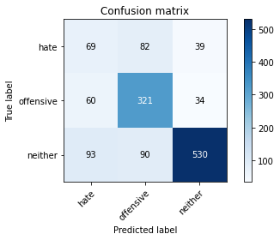

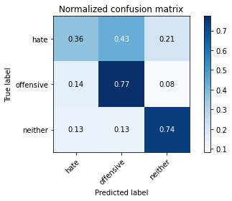

precision recall f1-score support

hate 0.31 0.36 0.33 190

offensive 0.65 0.77 0.71 415

neither 0.88 0.74 0.81 713

accuracy 0.70 1318

macro avg 0.61 0.63 0.62 1318

weighted avg 0.73 0.70 0.71 1318

average eval_loss: 0.956252820789814, accuracy: 0.6980273141122914

training 5 epoch...

63.004108905792236 seconds used......

5 training finished! average train loss: 0.07389405446373817

evaluating...

Confusion matrix, without normalization

[[ 49 72 69]

[ 40 303 72]

[ 69 38 606]]

Normalized confusion matrix

[[0.25789474 0.37894737 0.36315789]

[0.09638554 0.73012048 0.17349398]

[0.09677419 0.05329593 0.84992987]]

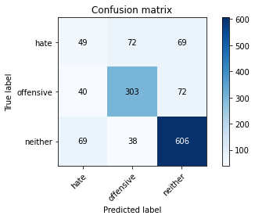

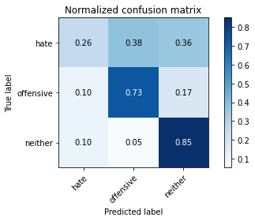

precision recall f1-score support

hate 0.31 0.26 0.28 190

offensive 0.73 0.73 0.73 415

neither 0.81 0.85 0.83 713

accuracy 0.73 1318

macro avg 0.62 0.61 0.61 1318

weighted avg 0.71 0.73 0.72 1318

average eval_loss: 1.1590993025086143, accuracy: 0.7268588770864947

training 6 epoch...

63.00477361679077 seconds used......

6 training finished! average train loss: 0.05030731392554684

evaluating...

Confusion matrix, without normalization

[[ 62 64 64]

[ 60 301 54]

[ 78 52 583]]

Normalized confusion matrix

[[0.32631579 0.33684211 0.33684211]

[0.14457831 0.7253012 0.13012048]

[0.10939691 0.07293128 0.81767181]]

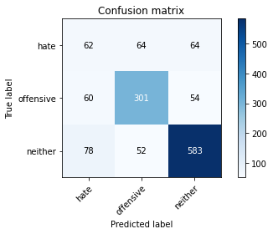

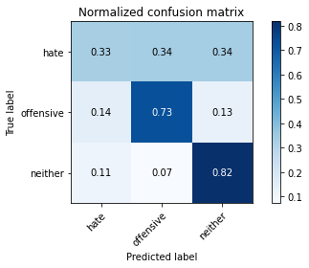

precision recall f1-score support

hate 0.31 0.33 0.32 190

offensive 0.72 0.73 0.72 415

neither 0.83 0.82 0.82 713

accuracy 0.72 1318

macro avg 0.62 0.62 0.62 1318

weighted avg 0.72 0.72 0.72 1318

average eval_loss: 1.1746179524696234, accuracy: 0.7177541729893778

training 7 epoch...

62.95757532119751 seconds used......

7 training finished! average train loss: 0.03278636085799832

evaluating...

Confusion matrix, without normalization

[[ 56 71 63]

[ 51 315 49]

[ 90 49 574]]

Normalized confusion matrix

[[0.29473684 0.37368421 0.33157895]

[0.12289157 0.75903614 0.11807229]

[0.12622721 0.0687237 0.80504909]]

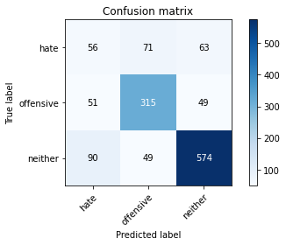

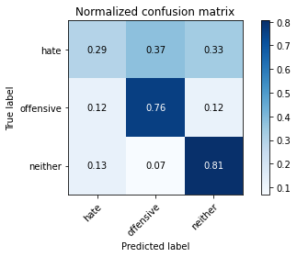

precision recall f1-score support

hate 0.28 0.29 0.29 190

offensive 0.72 0.76 0.74 415

neither 0.84 0.81 0.82 713

accuracy 0.72 1318

macro avg 0.62 0.62 0.62 1318

weighted avg 0.72 0.72 0.72 1318

average eval_loss: 1.27806353885116, accuracy: 0.7169954476479514

training 8 epoch...

63.04396939277649 seconds used......

8 training finished! average train loss: 0.029867294693090077

evaluating...

Confusion matrix, without normalization

[[ 44 82 64]

[ 27 342 46]

[ 57 77 579]]

Normalized confusion matrix

[[0.23157895 0.43157895 0.33684211]

[0.06506024 0.82409639 0.11084337]

[0.0799439 0.10799439 0.81206171]]

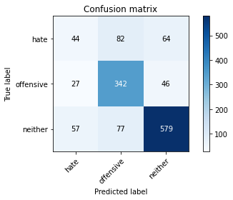

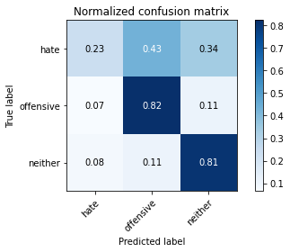

precision recall f1-score support

hate 0.34 0.23 0.28 190

offensive 0.68 0.82 0.75 415

neither 0.84 0.81 0.83 713

accuracy 0.73 1318

macro avg 0.62 0.62 0.62 1318

weighted avg 0.72 0.73 0.72 1318

average eval_loss: 1.366023264599569, accuracy: 0.7321699544764795

training 9 epoch...

63.033297538757324 seconds used......

9 training finished! average train loss: 0.02475789933240053

evaluating...

Confusion matrix, without normalization

[[ 52 74 64]

[ 44 310 61]

[ 68 54 591]]

Normalized confusion matrix

[[0.27368421 0.38947368 0.33684211]

[0.1060241 0.74698795 0.14698795]

[0.09537167 0.07573633 0.82889201]]

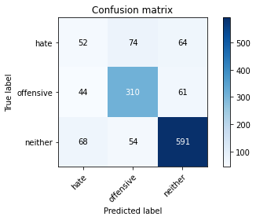

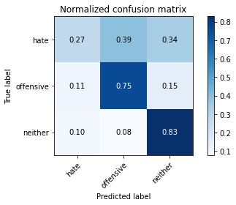

precision recall f1-score support

hate 0.32 0.27 0.29 190

offensive 0.71 0.75 0.73 415

neither 0.83 0.83 0.83 713

accuracy 0.72 1318

macro avg 0.62 0.62 0.62 1318

weighted avg 0.72 0.72 0.72 1318

average eval_loss: 1.3810766131588907, accuracy: 0.7230652503793626

training 10 epoch...

62.98141884803772 seconds used......

10 training finished! average train loss: 0.023381824329426776

evaluating...

Confusion matrix, without normalization

[[ 33 103 54]

[ 15 368 32]

[ 52 137 524]]

Normalized confusion matrix

[[0.17368421 0.54210526 0.28421053]

[0.03614458 0.88674699 0.07710843]

[0.07293128 0.19214586 0.73492286]]

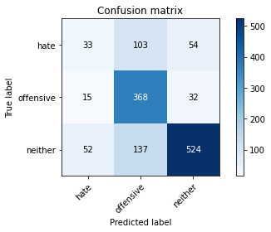

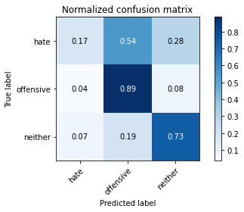

precision recall f1-score support

hate 0.33 0.17 0.23 190

offensive 0.61 0.89 0.72 415

neither 0.86 0.73 0.79 713

accuracy 0.70 1318

macro avg 0.60 0.60 0.58 1318

weighted avg 0.70 0.70 0.69 1318

average eval_loss: 1.6614601508234486, accuracy: 0.7018209408194234